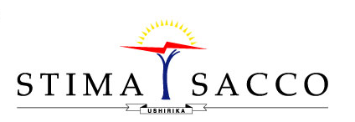

...empowering members for life

VACANCY ADVERTISEMENT
Society Vision: To redefine financial wellness.
Stima DT Savings and Credit Cooperative Society Limited (Stima Sacco) is a leading country-wide, fast growing, and licensed DTS (Deposit Taking Sacco). To achieve the planned growth, the Sacco is looking for qualified and competent persons to fill the following vacancy:

CHECK OFF ASSISTANT - CREDIT ADMINISTRATION
Job Summary
Reporting to the Credit Administrative Officer, the job holder will be responsible for monitoring performing loan portfolio of personal loans.
Key Tasks and Responsibilities
- Batching and disbursements of loans
- Daily monitoring of loans disbursements (ensure all postings are properly done)
- Daily monitoring of performing and watch loan portfolio
- Ensuring full loans documentation before disbursements
- Preparing of offer letters
- Compilation of CRB data
- Maintenance of the loans collateral register
- Monitoring and review of insurance covers for loan securities
- Ensuring adherence to the offer letter conditions
Qualifications
- Bachelors’ degree from a recognized institution.
- Professional: CPA II or equivalent required;
- Minimum two (2) years relevant experience at an equivalent position in a financial institution.
- Excellent interpersonal, communication and presentation skills with the ability to interact effectively with all levels of management and staff.
Interested Applicants should apply using the link provided on the Society website on or before 19th February 2022.

